

**Cricket Ireland Child Safeguarding Statement**

**Section 1 – Club Information**

***Connacht Cricket Union*** provides various sporting activities and opportunities for young people through participation in clubs, regional/provincial events and through our national teams.

* **Club Name:** Connacht Cricket Union
* **Sport:** Cricket
* **Location:** Connacht
* **Size (Number of staff/members):** 13 Committee members/9 Affiliated Clubs

**Section 2 - Principles to safeguard children from harm**

***Connacht Cricket Union*** is committed to safeguarding children and by working under the guidance of our Safeguarding Policies our staff, both volunteers and employed, working with our young people, throughout the organisation, seek to create a safe environment for young people to grow and develop within sport. The following set of principles should be adhered to:

* **Importance of childhood** - The importance of childhood should be understood and valued by everyone involved in sport.
* **Needs of the child** - All children’s sport experiences should be guided by what is best for children. This means that adults should have a basic understanding of the emotional, physical and personal needs of young people.
* **Integrity in relationships** - Adults interacting with children in sport are in a position of trust and influence. They should always ensure that children are treated with integrity and respect, and the self-esteem of young people is enhanced.
* **Fair Play** - All children’s sport should be conducted in an atmosphere of fair play. The principles of fair play should always be emphasised, and organisers should give clear guidelines regarding acceptable standards of behaviour.
* **Quality atmosphere & ethos** - Children’s sport should be conducted in a safe, positive, and encouraging atmosphere.
* **Competition** - Competition is an essential element of sport and should be encouraged in an age appropriate manner. A child centred ethos will help to ensure that competition and specialisation are kept in their appropriate place.
* **Equality** - All children should be valued and treated in an equitable and fair manner regardless of ability, age, gender, religion, social and ethnic background or political persuasion.

**Section 3 - Risk Assessment**

This **Connacht Cricket Union** written Risk Assessment document indicates the areas of potential risk of harm, the likelihood of the risk occurring, and gives the required policy, guidance or process documents require to alleviate these risks.The list of risks identified and procedures to manage these risks are contained in the following categories:

|  |  |
| --- | --- |
| **Risk Identified** | **Procedure in place to manage risk identified** |
| **Club and Coaching Practices**   * Lack of coaching qualification. * Unauthorised photography & recording activities. * Behavioural Issues. * Lack of gender balance amongst coaches * Travelling & away trips * Lack of adherence with misc procedures in Safeguarding policy | * Safe Recruitment and Training Policy/ Child Safeguarding Training. * Social Media, Use of Video, Photography and Mobile Phones Guide * Code of Conduct / Child Safeguarding Training / Complaints & Disciplinary Policy / Anti-Bullying Policy. * Safe Recruitment and Training Policy / Women and Girl’s Strategy / Equality, Diversity & Inclusion Policy * Travelling abroad/overnight stay consent form/ Child Safeguarding Training/ Code of Conduct * Safeguarding Policy / Code of Conduct / Complaints & disciplinary Policy / Social Media, Use of Video, Photography and Mobile Phones Guide |
| **Complaints & Discipline**   * Lack of awareness of a Complaints & Disciplinary policy. * Complaints not being dealt with seriously | * Complaints & Disciplinary Policy * Complaints & Disciplinary Policy. |
| **Reporting Procedures**   * Lack of knowledge of organisational & statutory reporting procedures * Concerns of abuse or harm not reported. * Not clear who Young Person should talk to or report to. | * Roles and Responsibilities / Dealing with Child Protection Concerns / Code of Conduct. * Roles and Responsibilities / Dealing with Child Protection Concerns / Child Safeguarding Training – Level 1 * Post the names of CCO, DLP and Mandated person / Safeguarding Poster for Children’s Officer |
| **Use of Facilities**   * Unauthorised access to designated children’s play & practice areas & to changing rooms, showers, toilets etc….. * Unauthorised exit from children’s areas. * Photography, filming or recording in prohibited areas. * Missing or found child on site. * Children sharing facilities with adults e.g. dressing room, showers etc… | * Safeguarding Policy/ Changing Room Policy. * Safeguarding Policy. * Social Media, Use of Video, Photography and Mobile Phones Guide. * Missing or found child Policy. * Safeguarding Policy / Changing Room Policy |
| **Recruitment**   * Recruitment of inappropriate people. * Lack of clarity on roles. * Unqualified or untrained people in role. | * Safe Recruitment and Training Policy. * Safe Recruitment and Training Policy/ Roles and Responsibilities. * Safe Recruitment and Training Policy. |
| **Communications**   * Lack of awareness of ‘risk of harm’ with members and visitors. * No communication of Child Safeguarding Statement of Code of Conduct to members of visitors. * Unauthorised photography & recording of activities. * Inappropriate use of social media & communications by under 18’s * Inappropriate use of social media & communications with under 18’s. | * Child Safeguarding Statement (displayed) * Child Safeguarding Statement (displayed) / Code of Conduct (distribute). * Social Media, Use of Video, Photography and Mobile Phones Guide * Social Media, Use of Video, Photography and Mobile Phones Guide / Code of Conduct * Code of Conduct |
| **General Risk of Harm**   * Harm not being recognised. * Harm caused by:   Child to Child.  Coach to Child.  Volunteer to Child.  Member to Child.  Visitor to Child.   * General behavioural issues. * Issues of Bullying. * Vetting of staff/volunteers. * Issues of Online Safety | * Safeguarding Policy / Safe Recruitment and Training Policy / Roles and Responsibilities. * Safeguarding Policy / Safe Recruitment and Training Policy / Dealing with Child Protection Concerns. * Code of Conduct. * Anti-Bullying Policy. * Safe Recruitment and Training Policy / Vetting Policy. * Social Media, Use of Video, Photography and Mobile Phones Guide / Code of Conduct. |

The Risk Assessment was undertaken on **10/4/2025***.*

**Section 4 – Procedures**

Our Child Safeguarding Statement has been developed in line with requirements under the Children First Act 2015, Children First: National Guidance, Children (NI) Order 1995, and Tusla’s Child Safeguarding: A Guide for Policy, Procedure and Practice. In addition to our Risk Assessment document described above, there are further procedures that support our intention to safeguard children while they are availing of our activities.

(***Connacht Cricket Union***) has the following procedures in place as part of our Safeguarding Policies:

* Procedures for the management of allegations of abuse or misconduct by staff or volunteers against a child availing of our activities.
* Procedures for the safe recruitment of staff and volunteers to work with children in our activities.
* Procedures for access to child safeguarding training and information, including the identification of the occurrence of harm.
* Procedure for reporting of child protection or welfare concerns to Statutory Authorities.
* Procedure for maintaining a list of the persons (if any) in the relevant service who are mandated persons.
* Procedure for appointing a relevant person.

***Please note that all procedures listed are available on request.***

The Child Protection Officer for Connacht Cricket Union is Sarah Barry. Sarah can be contacted on +353 860383477 or childprotection@connachtcricket.ie.

**Section 5 – Implementation**

We recognise that implementation is an ongoing process. Our club is committed to the implementation of this Child Safeguarding Statement and the procedures that support our intention to keep children safe from harm while availing of our activities.

Please note the following:

* That all staff have been furnished with a copy of this statement.
* This statement is available to parents/guardians, the Agency and members of the public on request.
* This statement will be displayed via our website by Connacht Cricket Union.

This Child Safeguarding Statement will be reviewed on the **9th April 2026**.

Signed: Date: 10/04/2025

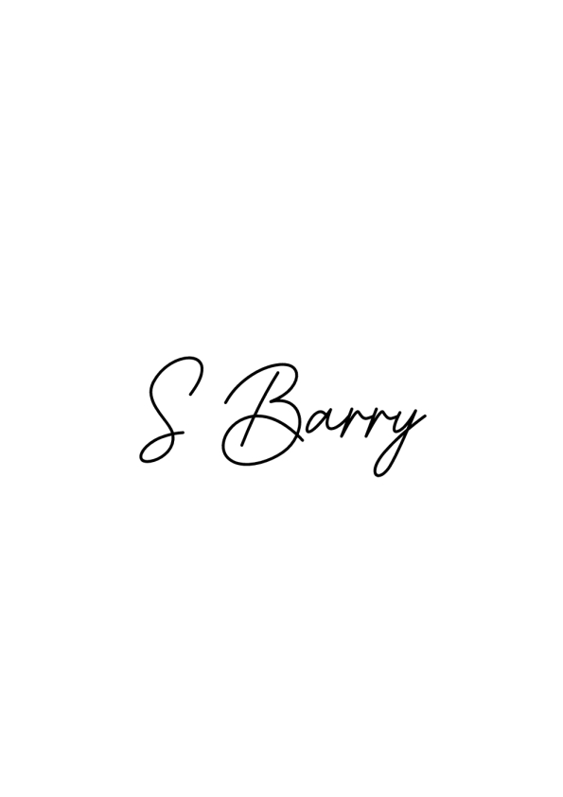

On behalf of ***Connacht Cricket Union***

Name: Sarah Barry Phone no: 086-0383477

For queries on this Child Safeguarding Statement, please contact***Sarah Barry****.*