Risk Assessment for Connacht Cricket Union

This risk assessment considers the potential for harm to come to children whilst they are affiliated to Connacht Cricket union. This risk assessment precedes the Child Safeguarding Statement (Section 11 (1b) Children First Act 2015) which is developed following this risk assessment process. In accordance with the requirements of Section 11 (1) of the Children First Act 2015 the risk is of abuse and not general health and safety risk (covered under a separate H&S policy and risk assessment).
Section 11 (1) of the Children First Act 2015 states that where a person proposes to operate as a provider of a relevant service, he or she shall, within 3 months from the date on which he or she commences as such a provider —
- Undertake an assessment of any potential for harm to a child while availing of the service (in this section referred to as a “risk”.

Potential risk of harm to children |  | Likelihood of harm happening L-M-H | Required Policy, Guidance and Procedure document | Responsibility  Club/Region/National | Further action required …
CLUB & COACHING PRACTICES
Lack of coaching qualification (including safeguarding training) |  | H | - Safe Recruitment and Training Policy  - Child Safeguarding Training | CI/CCU/Club | Proof of qualification to be confirmed
Unauthorised photography & recording activities |  |  | - Social Media, Use of Video, Photography and Mobile Phones Guide |  | Ongoing review
Behavioural Issues – peer to peer and leader behaviour |  |  | - Sports Leader Code of Conduct  - Code of Conduct for Young People  - Child Safeguarding Training  - Anti-Bullying Policy  - Complaints & Disciplinary Policy |  | Ongoing review
Lack of gender balance amongst coaches |  |  | - Safe Recruitment and Training Policy  - Women and Girl’s Strategy  - Equality, Diversity & Inclusion Policy |  | Ongoing review  Women and Girl’s strategy under development
Travelling and away trips |  |  | - Travelling abroad/overnight stay consent form  - Safe Recruitment and Training Policy  - Vetting Policy  - Sports Leader Code of Conduct  - Code of Conduct for Parent/Guardian  - Code of Conduct for Young People |  | Ongoing review
Lack of adherence with misc procedures in Safeguarding policy (i.e. mobile, photography, transport) |  |  | - Safeguarding policy  - Sports Leader Code of Conduct  - Code of Conduct for Young People  - Complaints & disciplinary policy  - Social Media, Use of Video, Photography and Mobile Phones Guide |  | Ongoing review
COMPLAINTS & DISCIPLINE
Lack of awareness of a Complaints Procedure & Disciplinary Policy |  | H | - Complaints Procedure & Disciplinary Policy | Club | Greater communication required
Complaints not being dealt with seriously |  |  | - Complaints & Disciplinary Policy |  | Ongoing review
REPORTING PROCEDURES
Lack of knowledge of organisational and statutory reporting procedures |  | H | - Roles and Responsibilities  - Dealing with Child Protection Concerns  - Sports Leader Code of Conduct  - Code of Conduct for Parent/Guardian  - Code of Conduct for Young People | NGB  Mandated Person  DLP | Make policies and procedures available  Include in Safeguarding Training (L1)  Include in Coach Education Training
Concerns of abuse or harm not reported |  |  | - Roles and Responsibilities  - Dealing with Child Protection Concerns  - Child Safeguarding Training – Level 1 | Mandated Person  DLP | Include in Safeguarding Training (L1)  Publicise names of CCOs, DLPs, MP(s)  Publicise internal and external reporting procedures
Not clear who Young Person should talk to or report to |  |  | - Post the names of CCOs, DLPs and MP  - Safeguarding Poster for Children’s Officer | Club Children’s Officer  DLP | Names on website of CI CCO, DLP and PU DLP’s  Communicate to clubs
FACILITIES
Unauthorised access to designated children’s play & practice areas and to changing rooms, showers, toilets etc. |  | H | - Safeguarding Policy  - Changing Room Policy |  | Clarify responsibilities before session starts
Unauthorised exit from children’s areas |  |  | - Safeguarding Policy |  | Clarify roles and responsibilities before session starts
Photography, filming or recording in prohibited areas |  |  | - Social Media, Use of Video, Photography and Mobile Phones Guide |  | Enforce policy in private changing and wet areas
Missing or found child on site |  |  | - Missing or found child Policy |  | Refer to policy and inform Gardai/PSNI
Children sharing facilities with adults e.g. dressing room, showers etc. |  |  | - Safeguarding Policy  - Changing Room Policy |  | Plan with facilities management to create a suitable child centred environment in shared facilities
RECRUITMENT
Recruitment of inappropriate people |  | H | - Safe Recruitment and Training Policy |  | Ongoing review
Lack of clarity on roles |  |  | - Safe Recruitment and Training Policy  - Roles and Responsibilities |  | Check job description  Put supervision in place
Unqualified or untrained people in role |  |  | - Safe Recruitment and Training Policy |  | Check qualification  Ongoing review
COMMUNICATIONS AND SOCIAL MEDIA
Lack of awareness of ‘risk of harm’ with members and visitors | H |  | - Child Safeguarding Statement - displayed | DLP  Club Children’s Officer | Communicate Child Safeguarding Statement
No communication of Child Safeguarding Statement or Code of Conduct to  members or visitors |  |  | - Child Safeguarding Statement – displayed  - Code of Conduct for Sports Leader, Parent/Guardian and Young People for distribution | Club Executive  DLP  Club Children’s Officer | Communicate Child Safeguarding Statement  Distribute Code as appropriate  Distribute Code as appropriate
Unauthorised photography & recording of activities |  |  | - Social Media, Use of Video, Photography and Mobile Phones Guide |  | Constant review
Inappropriate use of social media and communications by under 18’s |  |  | - Social Media, Use of Video, Photography and Mobile Phones Guide  - Code of Conduct for Young People |  | Communicate Policy to PU’s and clubs
Inappropriate use of social media and communications with under 18’s |  |  | - Sports Leaders Code of Conduct. |  | Ongoing review
GENERAL RISK OF HARM
Harm not being recognised |  |  | - Safeguarding Policy  - Safe Recruitment and Training Policy  - Roles and Responsibilities |  | National Provincial and Club DLP and CO’s in place.  Review reporting process  Informal consultation with Tusla/HSCT
Harm caused by  - child to child  - coach to child  - volunteer to child  - member to child  - visitor to child |  |  | - Safeguarding Policy  - Safe Recruitment and Training Policy  - Dealing with Child Protection Concerns |  | Child Protection reporting process to Tusla/HSCT or the Gardai/PSNI
General behavioural issues  Issues of Bullying.  Vetting of staff/volunteers.  Issues of Online Safety |  |  | - Codes of Conduct for Sports Leader, Parents/Guardians and Young People  - Anti-Bullying Policy.  - Safe Recruitment and Training Policy  - Vetting Policy  - Social Media, Use of Video, Photography and Mobile Phones Guide |  | Take disciplinary action where necessary  Sign code of conduct

Explanation of terms used:

- Potential risk of harm to children – these are identified risks of harm to children whilst accessing activities in the Club/Region/Province/NGB.
- Likelihood of harm happening – the likelihood of the risk occurring in the club/region/NGB measured by you as Low/Medium or High.
- Required Policy, Guidance and Procedure document – indication of the policy required to alleviate the risk.
- Responsibility – provider should indicate where the responsibility for alleviating the risk lies.
- Further action… - indicates further action that might be necessary to alleviate any risk ongoing.

This Risk Assessment document has been discussed and completed by (Connacht Cricket Union) on _10_ /_04_ /2025_
Signed: 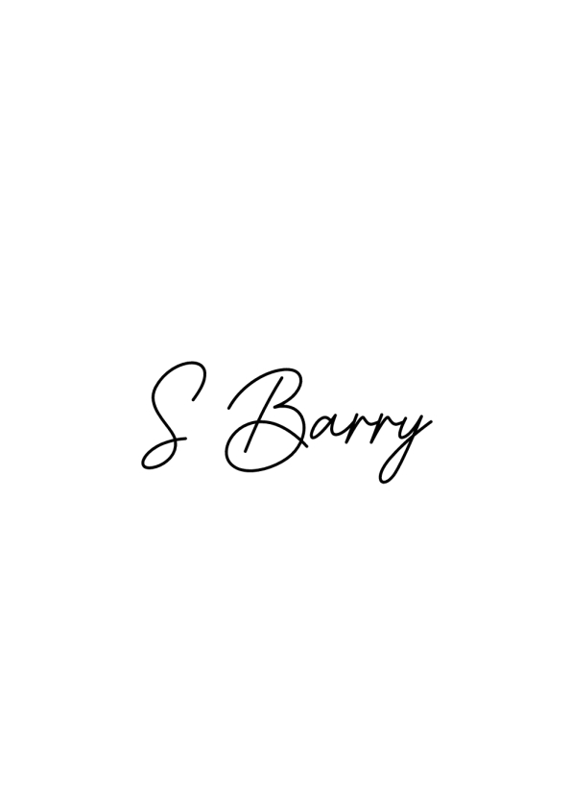 Signed: 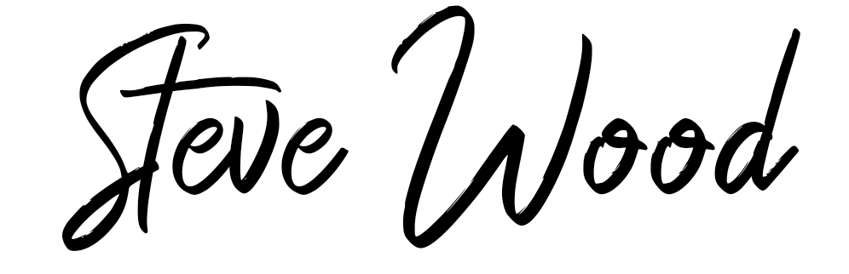
Name: Sarah Barry Name: Steven Wood
Role: Child Protection Officer Role: Secretary
Date: 10/04/2025 Date: 10/04/2025

